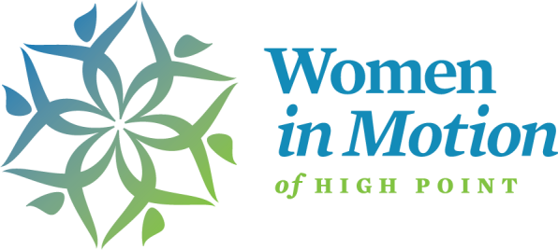
GRANT APPLICATION
Application Deadline: July 15, 2022
Women In Motion seeks to partner with community organizations to create solutions that will enable women in the workforce to ensure economic and professional growth leading to additional leadership in our communities. Our areas of focus are:

- Education: Women need additional education to help them negotiate and advocate for themselves and their families.
- Mentorship: Women need better systems for networking and encouraging growth in each other.
- Resources: Women, especially women small business owners, expressed a need to tap into resources that already exist in the community in order to increase their professional and business success.
- Wellness: Women seek to balance personal wellness and professional success with professional and family demands.

Application and Document Submission Instructions:
- Complete and submit “General Information” and “Program/Project Information”
- Include a copy of your IRS determination letter or proof of charitable status if classified as a church or school
- Include a budget template for your program and most recently filed tax return or postcard
- Include a balance sheet and income statement (P&L) for your last fiscal year and current year-to-date
- Include a list of your Board of Directors

All documents must be submitted via email to info@womeninmotionhp.org in one of the following formats: Word, Excel or PDF. Image files will not be accepted.

All applications must be in the office no later than 5 p.m., July 15, 2022.
Finalists will be contacted by June 25 to schedule a site visit the week of August 8th.

PLEASE COMPLETE THE FOLLOWING:
General Information: Please check one: ☐NEW Program/Project ☐EXISTING Program/Project

Organization Name:
Complete Mailing Address:
Organization Phone Number:
Website address:
Contact Name and Title:
Contact’s email address:
Contact’s phone number:
Executive Director’s name:
Executive Director’s email address:
Board Chairman’s name:
Board Chairman’s email address:
Project Title:
Priority Area(s) Addressed:
Total Project Cost:
Amount Requested:
Executive Director’s Signature:
Board Chairman’s Signature:

PLEASE COMPLETE THE FOLLOWING:
Program/Project Information: Programs should pertain to one or more of Women In Motion’s four identified areas of need. The primary desired outcome is to improve the personal, economic or professional development of women in the workforce. A secondary desired outcome is to increase the number of women willing and able to take on leadership roles in the communities we serve. We welcome pilot programs that target under-represented women in the community.
- Education - How can your program help women in the workforce learn the skills necessary for personal or professional success?

- Mentoring - How can your program provide mentoring for women looking to increase their leadership opportunities?

- Resources - How can your program provide access to resources needed to help women in the workforce, including entrepreneurs and small business owners

- Wellness - How can your program increase women’s sense of overall wellness takng into account emotional, mental and physical health?

In a separate document, using a maximum of 5 pages, provide thorough descriptions of the following:

  - Organization: Describe your organization’s mission, its work in High Point, Archdale, Trinity, Thomasville or Jamestown, and the populations you serve.
  - Need: Describe the need for this proposed project/program including relevant supporting evidence and how the program has been designed to meet the specific needs of women in one or more of the four identified areas of need listed above.
  - Capacity: Describe your organization’s capacity to serve women in the workforce and how it fits with your
organization’s mission. List past or current programs serving women in your organization.
  - Target population: Identify the target population of the proposed project/program. How will you recruit participants? How many participants do you plan to serve with this grant?
  - Strategies: Describe the specific activities and strategies that will take place in this project. Does the person/people administering this program have in-depth knowledge of the population being served? Please explain. What is the start and end date of your project?
  - Outcomes: What are the main goals you have for your program? How will you measure success of your program and what tools or tactics will you use to measure success?
  - Sustainability: Does your organization intend to sustain this project/program in the future? If yes, please explain. Multi-year requests will NOT be considered.
  - Possible Site Visit: What are your top three weekdays available between August 8th – 11th?

Budget Request:
You must submit a line-item budget request. You may use the template below or attach your own budget document. Although your total project budget may exceed your total request to Women in Motion, your total grant request should not exceed $5,000.
Source of Project Income/Funds: | Project Income/Funding:
WIM Grant Request:
(Cannot exceed $5000)
Total Project Income/Funds:

Description of Project Expenses: | Project Expenses:
Total Project Expenses:

Net/Project Balance:
(Total Income – Total Expenses)

